MC-25 Compiler - Peephole Optimization Report

1. Introduction
This report presents the peephole optimization implemented for the MC-25 compiler as part of Team Project 2. The objective of the optimization is to reduce unnecessary MIPS instructions generated by the compiler while preserving the correctness of the generated program.
The optimization was implemented in the compiler's codegen.c file. The generated MIPS assembly was tested using MARS 4.5, and Instruction Statistics were used to compare the unoptimized and optimized versions.

2. Objective
The main objective of the optimization is to identify and remove redundant MIPS instructions that do not contribute to the final program result.
Two redundant instruction patterns were targeted:
- add $t0, $t0, $zero, which leaves the value of $t0 unchanged.
- A redundant load immediately following a store to the same memory location, such as:
sw $t0, x
lw $t0, x
When the value stored in x is already available in $t0, loading it immediately back into $t0 is unnecessary.
Removing these instructions reduces the number of instructions executed while maintaining the same program output.

3. Peephole Optimization Implementation
The peephole optimization was implemented in codegen.c through the peephole_optimize() function.
The optimization examines the generated MIPS instruction sequence and removes recognized redundant instruction patterns. The optimization is applied before the generated assembly is written to the output file.
The following redundant instruction was removed:
add $t0, $t0, $zero
The optimizer also identifies the following store-load sequence:
sw $t0, x
lw $t0, x
and removes the unnecessary lw instruction.
The optimized instruction sequence therefore performs the same computation with fewer executed instructions.

4. Unoptimized and Optimized Code

4.1 Unoptimized Code
Before applying the peephole optimization, the generated code contained redundant instructions:
main:
li $t0, 5
sw $t0, x
lw $t0, x
addiu $sp, $sp, -8
sw $t0, 4($sp)
li $t0, 10
addiu $sp, $sp, -8
sw $t0, 4($sp)
li $t0, 2
lw $t1, 4($sp)
addiu $sp, $sp, 8
mul $t0, $t1, $t0
lw $t1, 4($sp)
addiu $sp, $sp, 8
add $t0, $t1, $t0
add $t0, $t0, $zero
move $a0, $t0
li $v0, 1
syscall
li $v0, 10
syscall
Two examples of redundant operations are visible in this version:
lw $t0, x
and:
add $t0, $t0, $zero

4.2 Optimized Code
After applying the peephole optimization, the redundant instructions were removed:
main:
li $t0, 5
sw $t0, x
addiu $sp, $sp, -8
sw $t0, 4($sp)
li $t0, 10
addiu $sp, $sp, -8
sw $t0, 4($sp)
li $t0, 2
lw $t1, 4($sp)
addiu $sp, $sp, 8
mul $t0, $t1, $t0
lw $t1, 4($sp)
addiu $sp, $sp, 8
add $t0, $t1, $t0
move $a0, $t0
li $v0, 1
syscall
li $v0, 10
syscall
The optimized version removes the unnecessary load and the redundant addition while preserving the program's computation.

5. MARS Instruction Statistics
The two versions were executed using MARS 4.5 and analyzed using the MARS Instruction Statistics tool.
Version | Total Instructions | Program Output
Unoptimized | 23 | 25
Optimized | 20 | 25
Reduction | 3 | No change
The optimization reduced the number of executed instructions from 23 to 20.
The reduction is:
23−20=3 instructions23 - 20 = 3 \text{ instructions}
The percentage reduction is:
23−2023×100=13.04%\frac{23-20}{23}\times100 = 13.04\%
Therefore, the optimized version achieved an approximately 13.04% reduction in executed instructions.
Most importantly, both versions produced the same output:
25
This demonstrates that the optimization preserved the functional behavior of the program while reducing unnecessary instructions.

5.1 Profiling Result
The MARS profiling results can be summarized as follows:
- Unoptimized: 23 instructions
- Optimized: 20 instructions
- Instructions removed: 3
- Instruction reduction: 13.04%
- Unoptimized output: 25
- Optimized output: 25
- Functional behavior: Preserved
The results demonstrate that the peephole optimization successfully reduces instruction execution without changing the program's result.

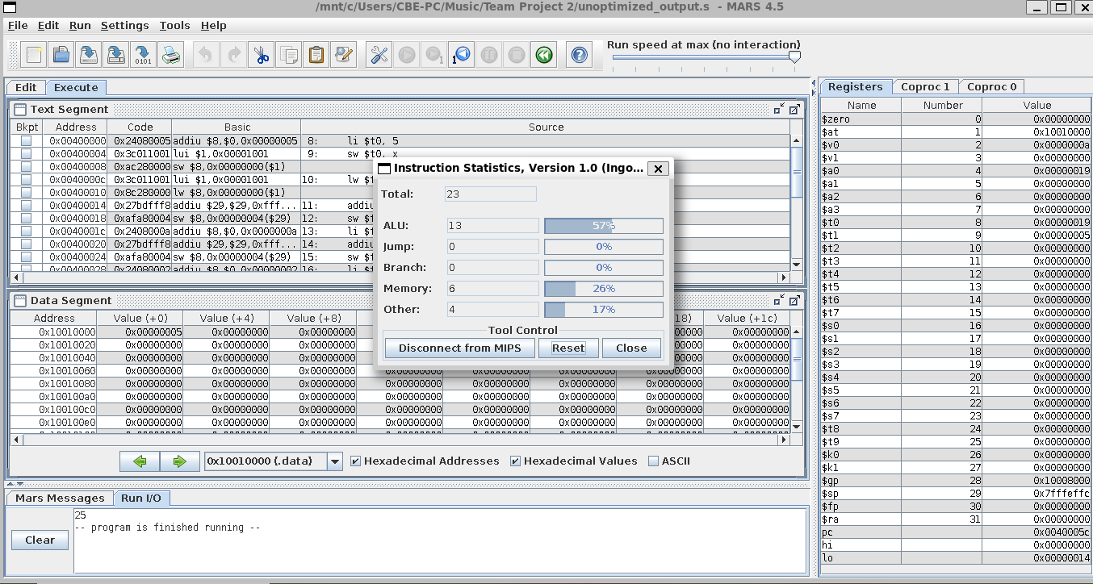

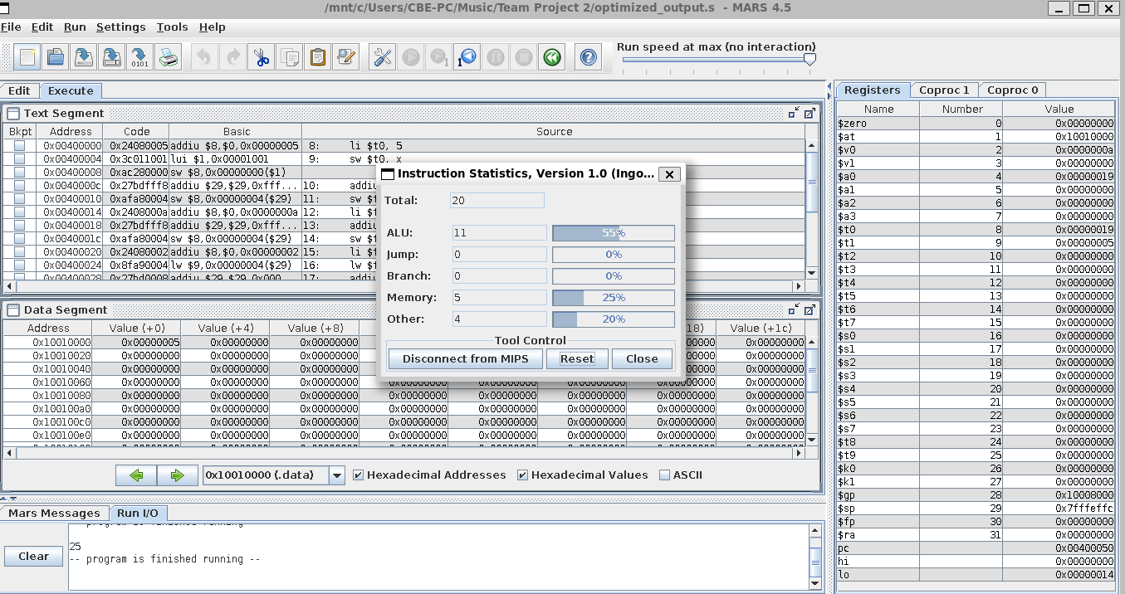

6. Conclusion
The MC-25 compiler's peephole optimization successfully removes redundant MIPS instructions generated during code generation. The optimization was implemented in codegen.c and tested using MARS 4.5.
MARS Instruction Statistics showed a reduction from 23 instructions to 20 instructions, corresponding to an approximately 13.04% reduction in executed instructions. At the same time, both the unoptimized and optimized programs produced the same output of 25.
These results demonstrate that the optimization improves the generated code by eliminating unnecessary instructions while preserving program correctness.
The optimization therefore satisfies the peephole optimization and MARS profiling objectives of Team Project 2.

